**Phase-End Project**

**Customer Support Logger**

**Screenshots:**

**Docker Desktop output after creating MVC application with docker support:**

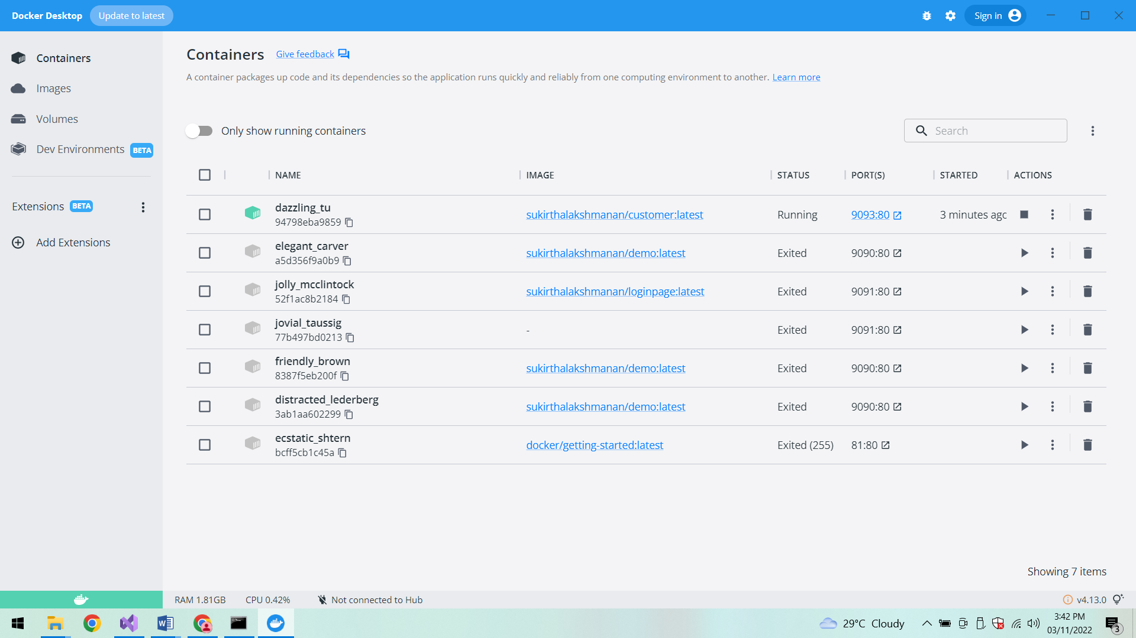

**After creating SQLServer database on Azure**

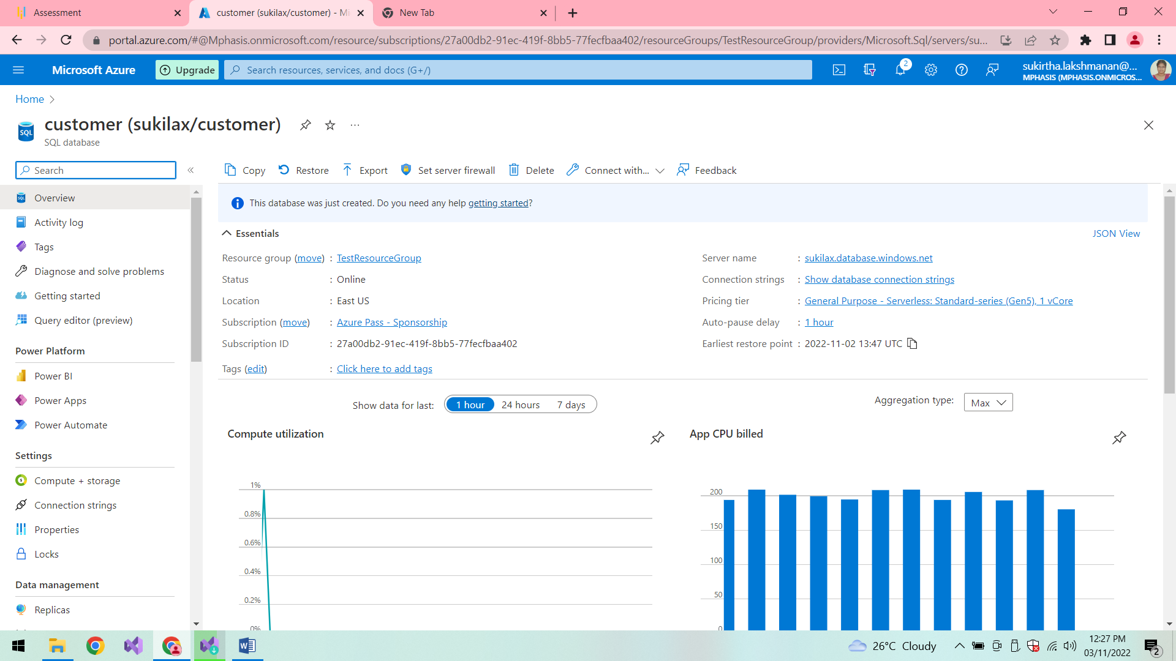

**Azure database in Local machine:**

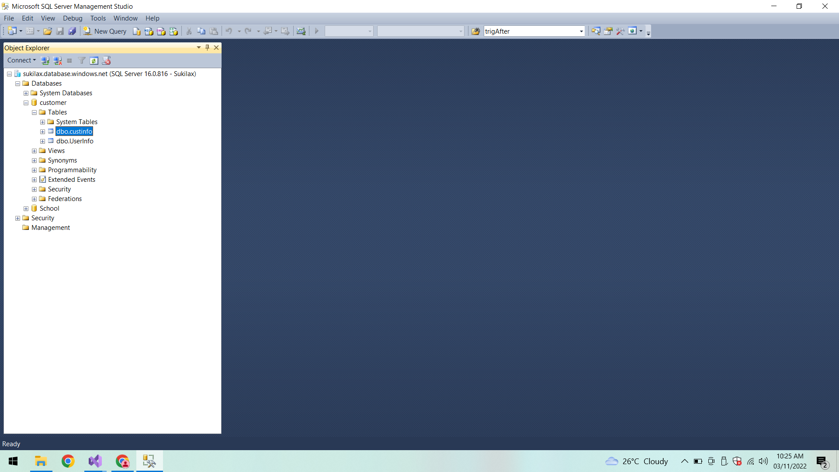

**UserInfo:**

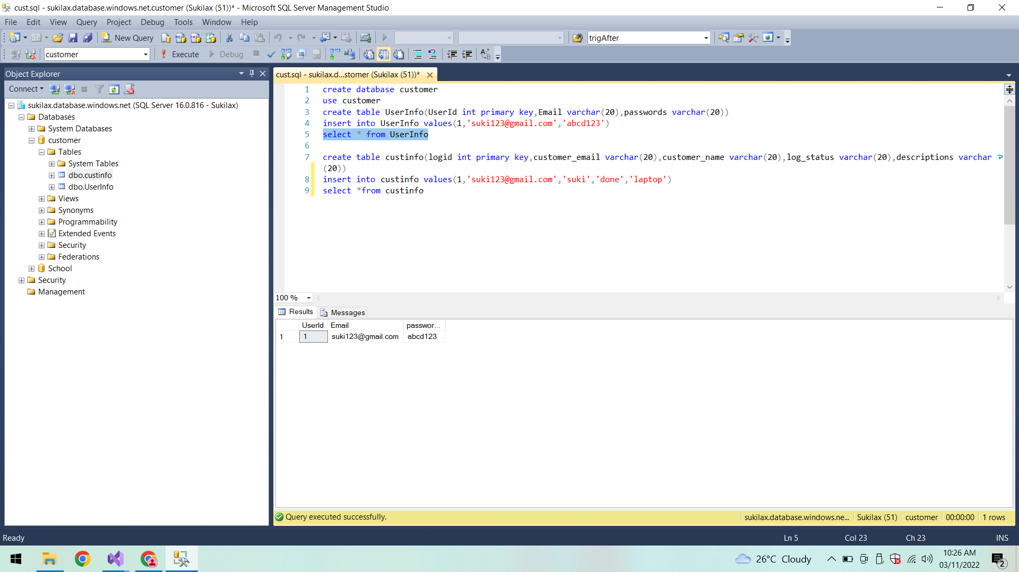

**Custinfo:**

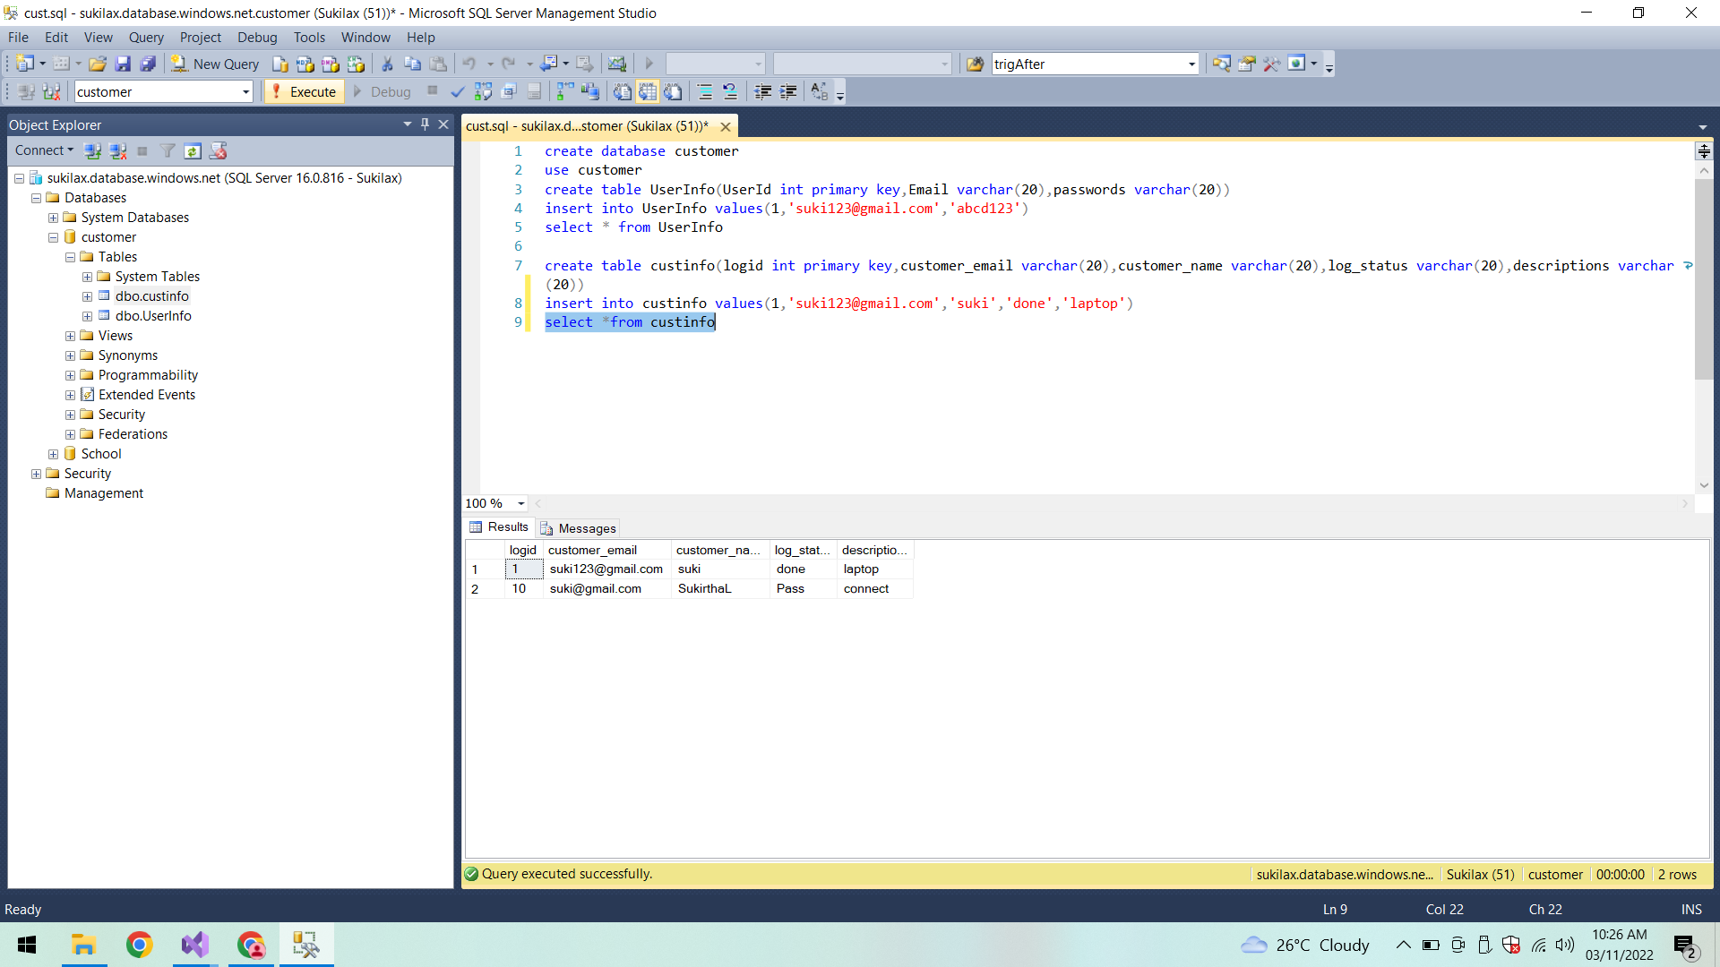

**Testing All Test cases:**

**UserInfo and CustInfo Test cases:**

All test cases passed here.

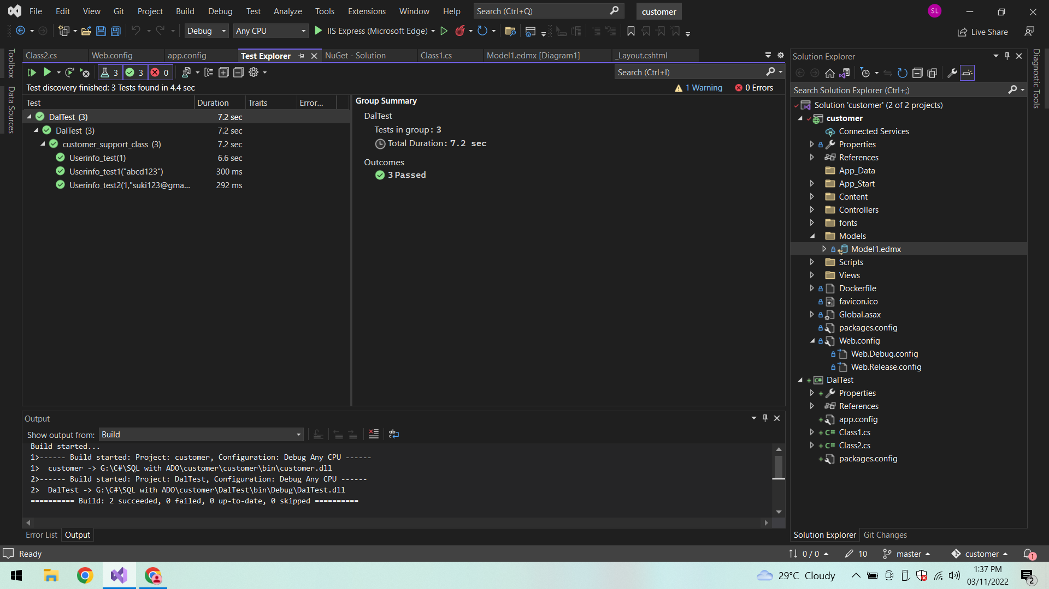

**UserInfo_test(1):**

In CustInfo On Testing the Log id:

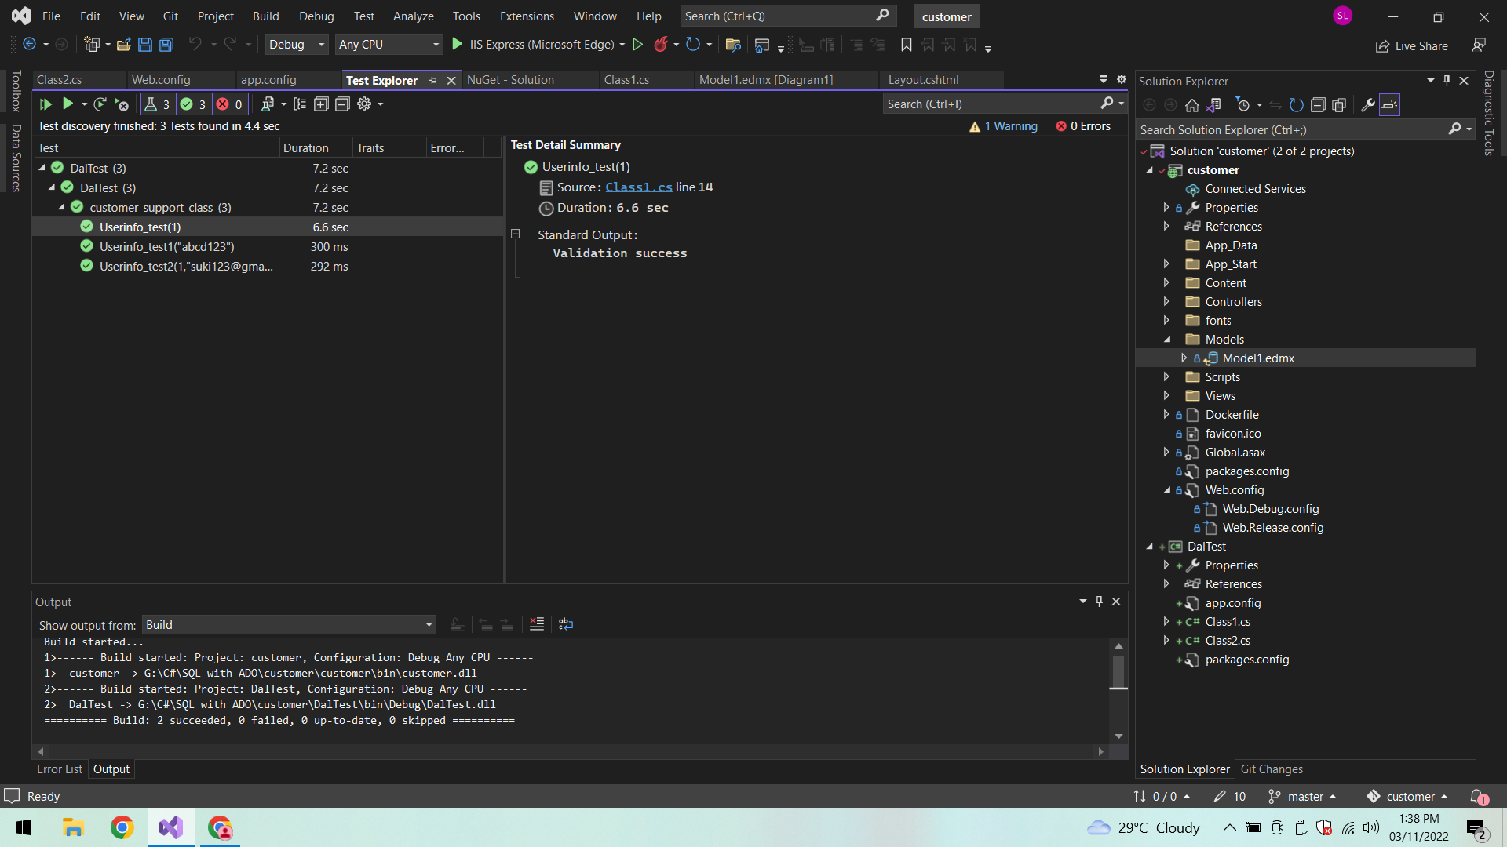

**Checking Password in login page:**

**Test case Passed:**

Giving the same password as in Azure database so that Testcase passed.

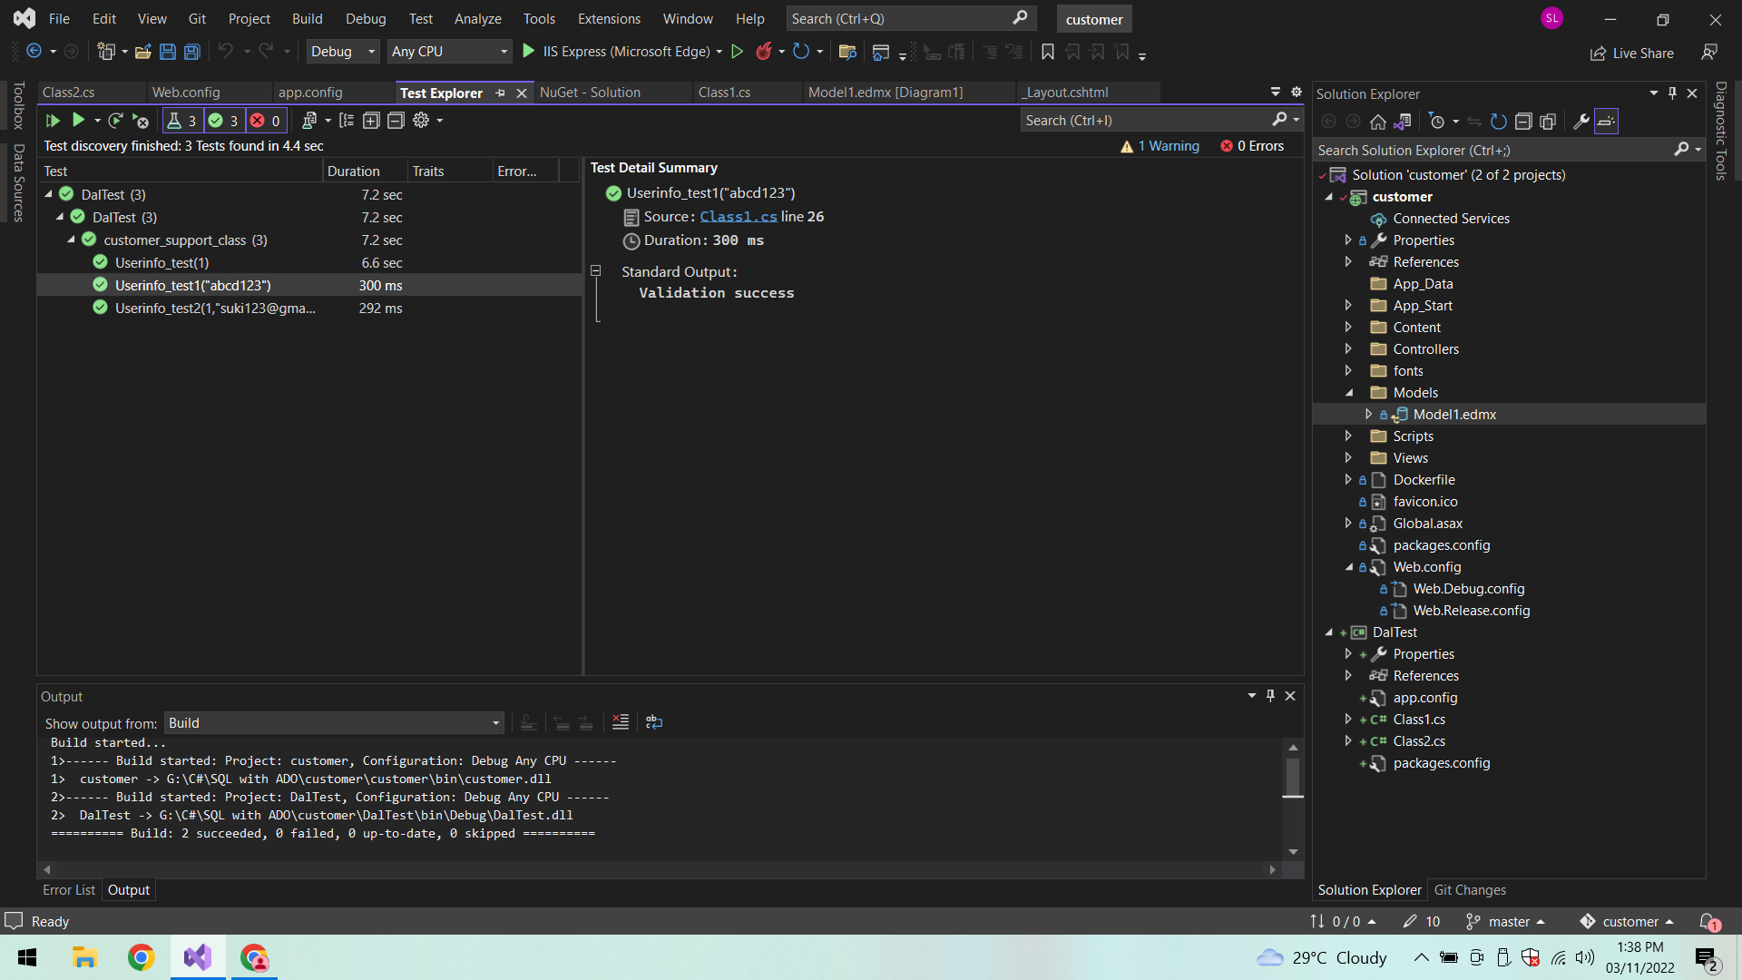

**Test case Failed:**

**Incorrect password:**

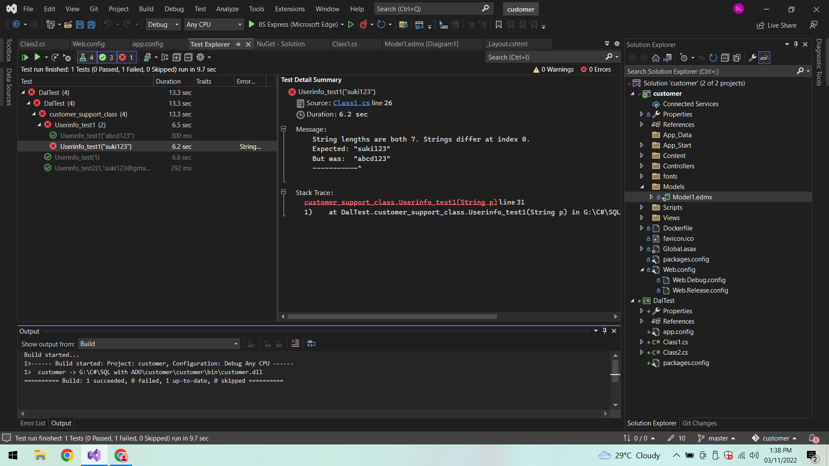

**Checking Email and UserId:**

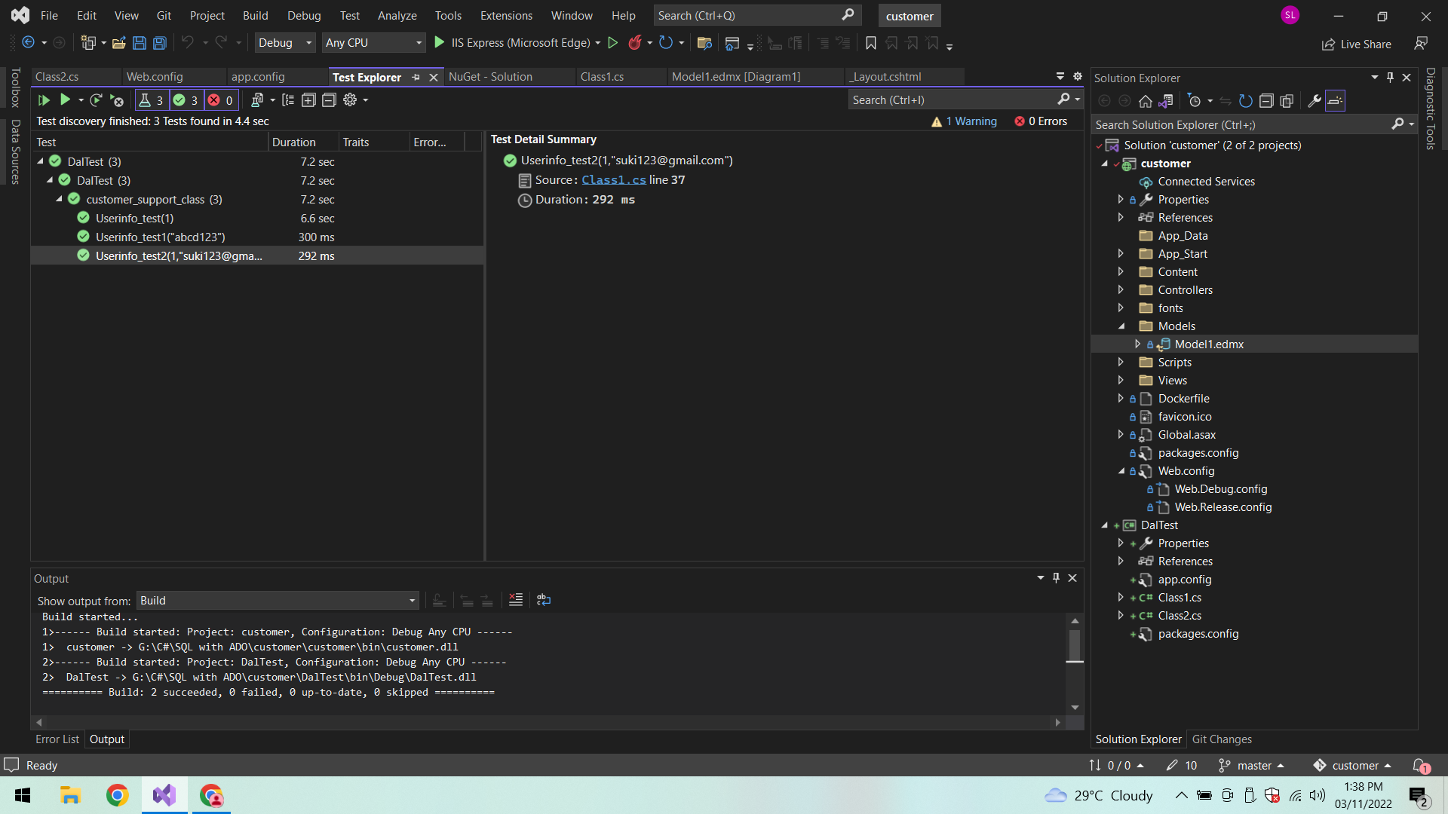

**After executing MVC application**

**a. Customer executive login page:**

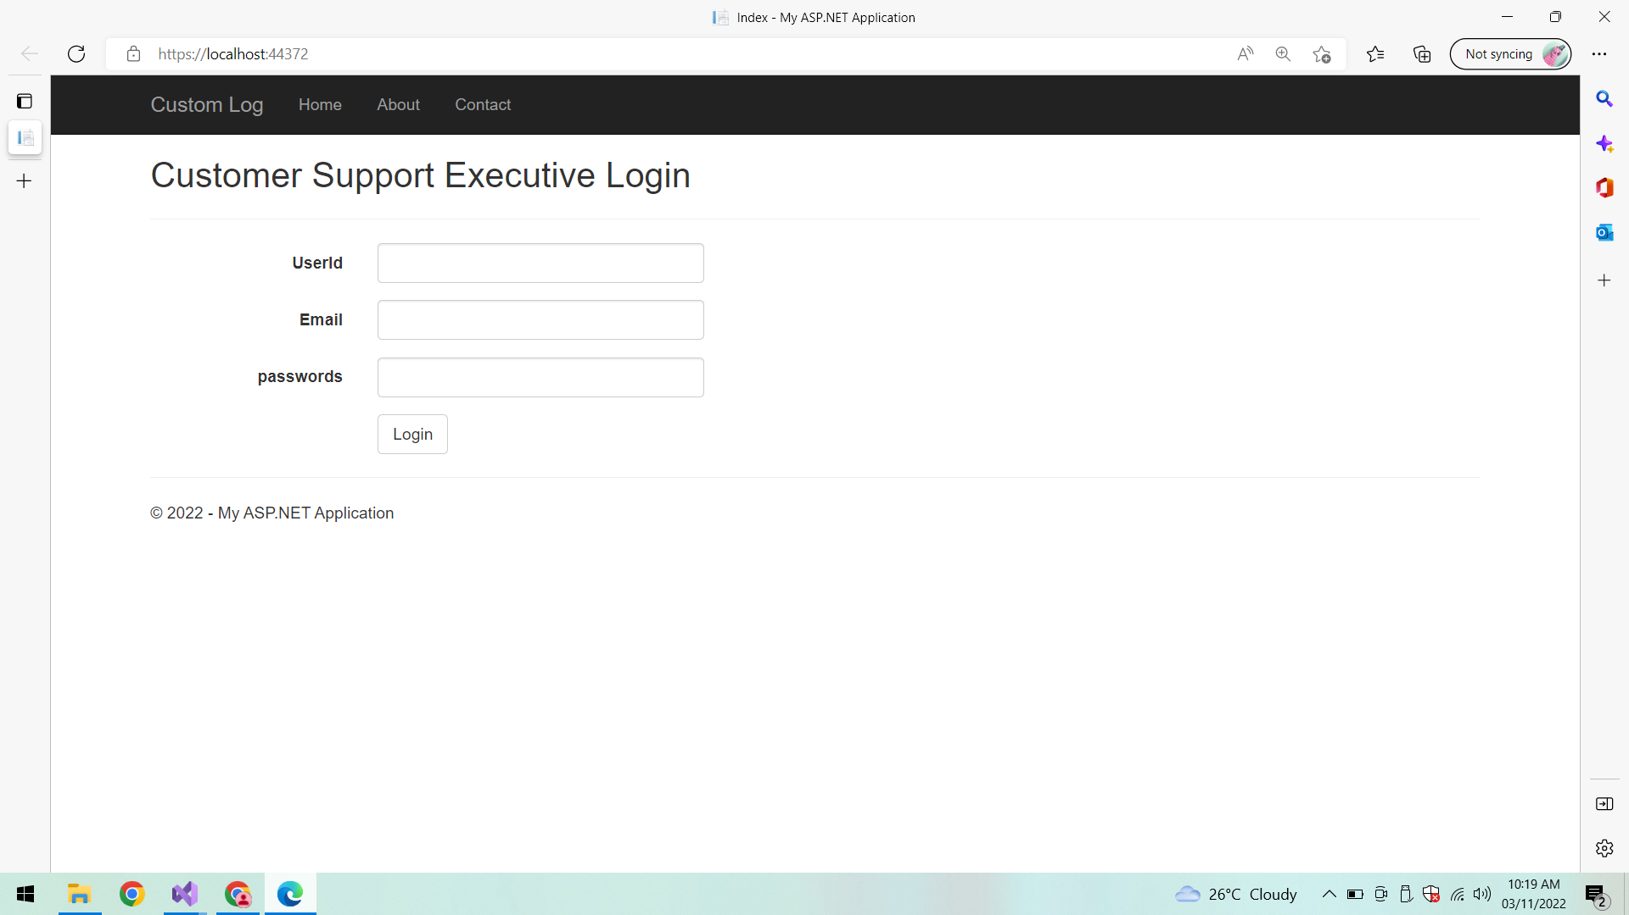

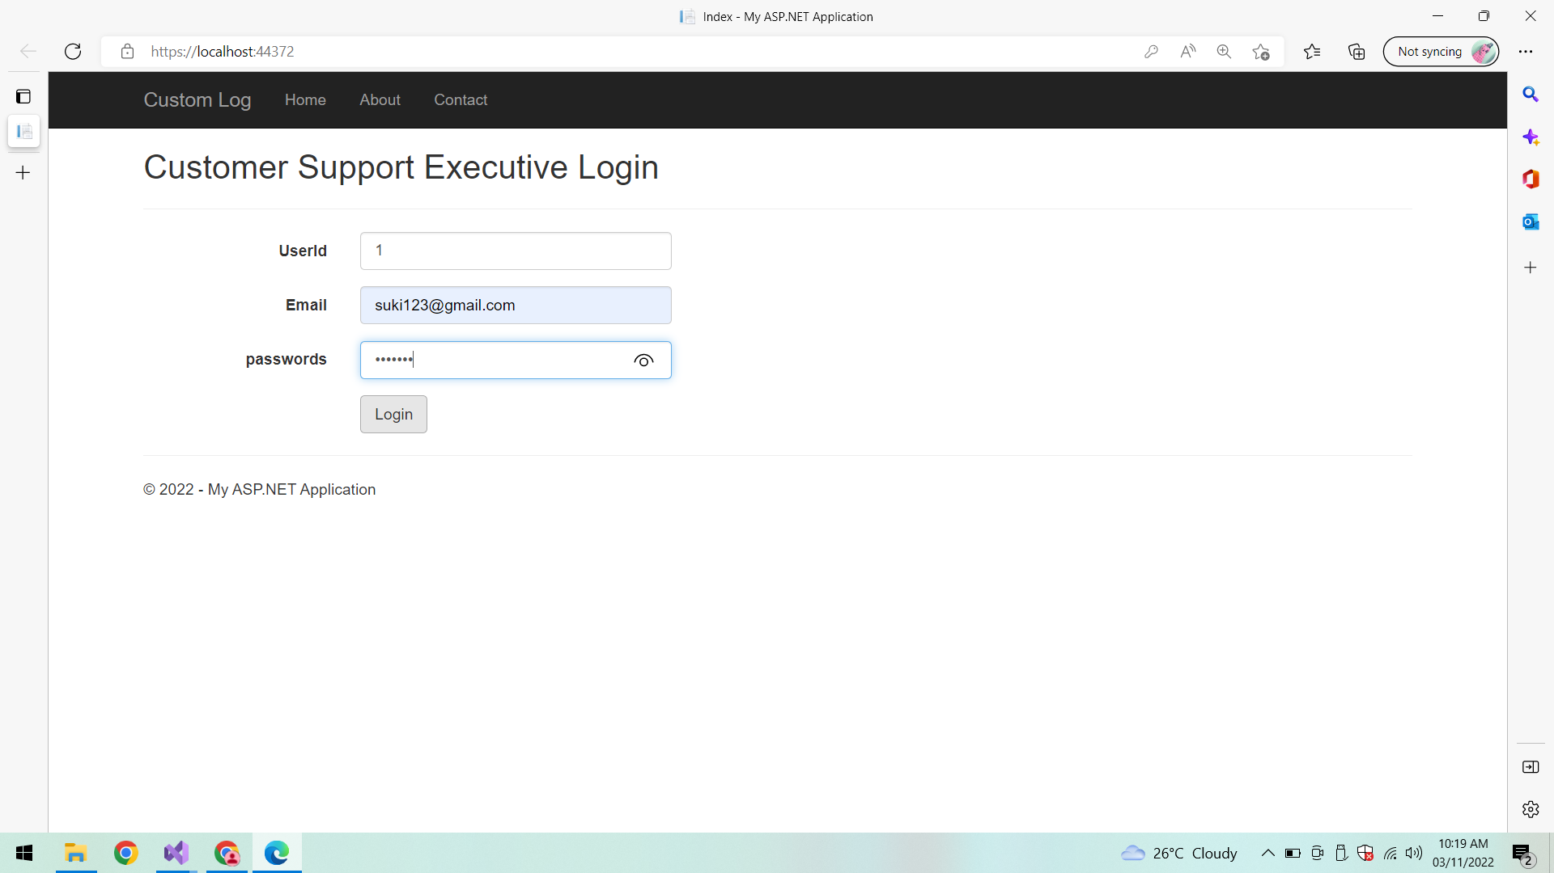

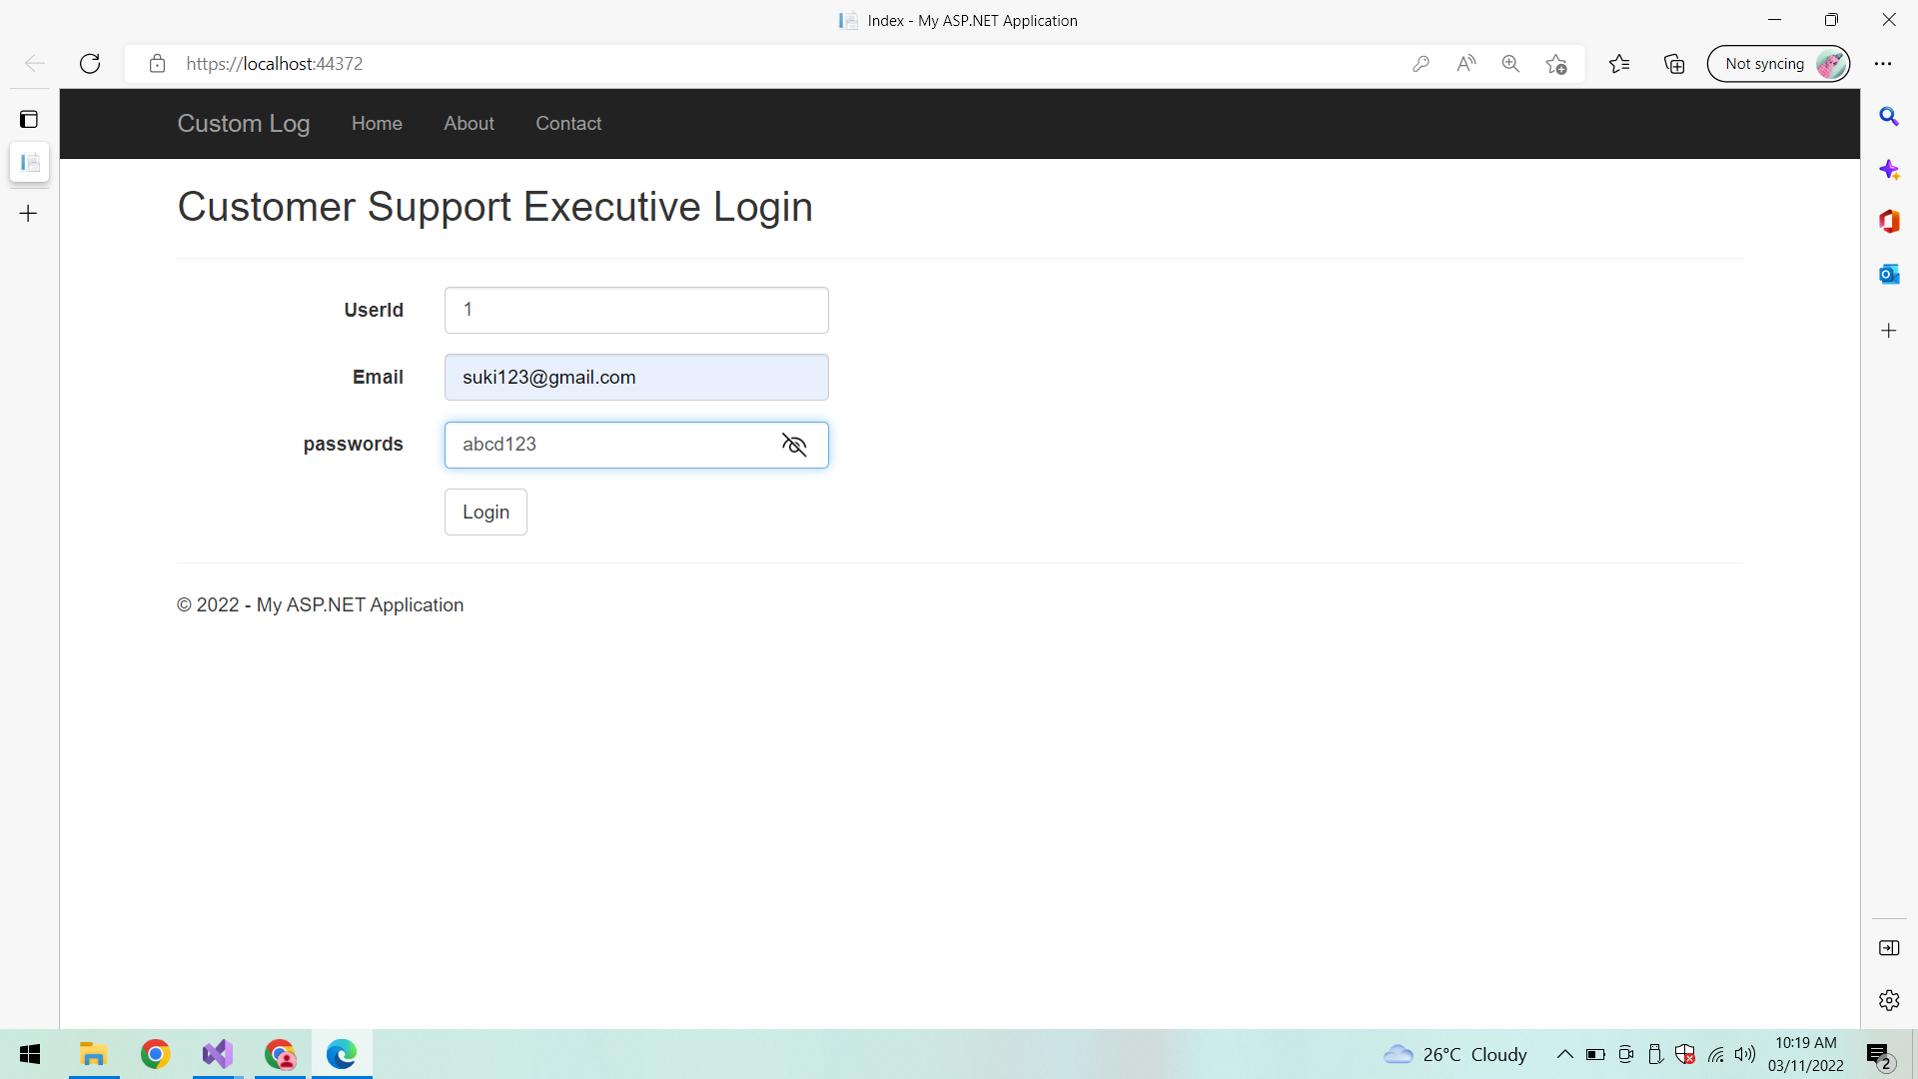

**Login:**

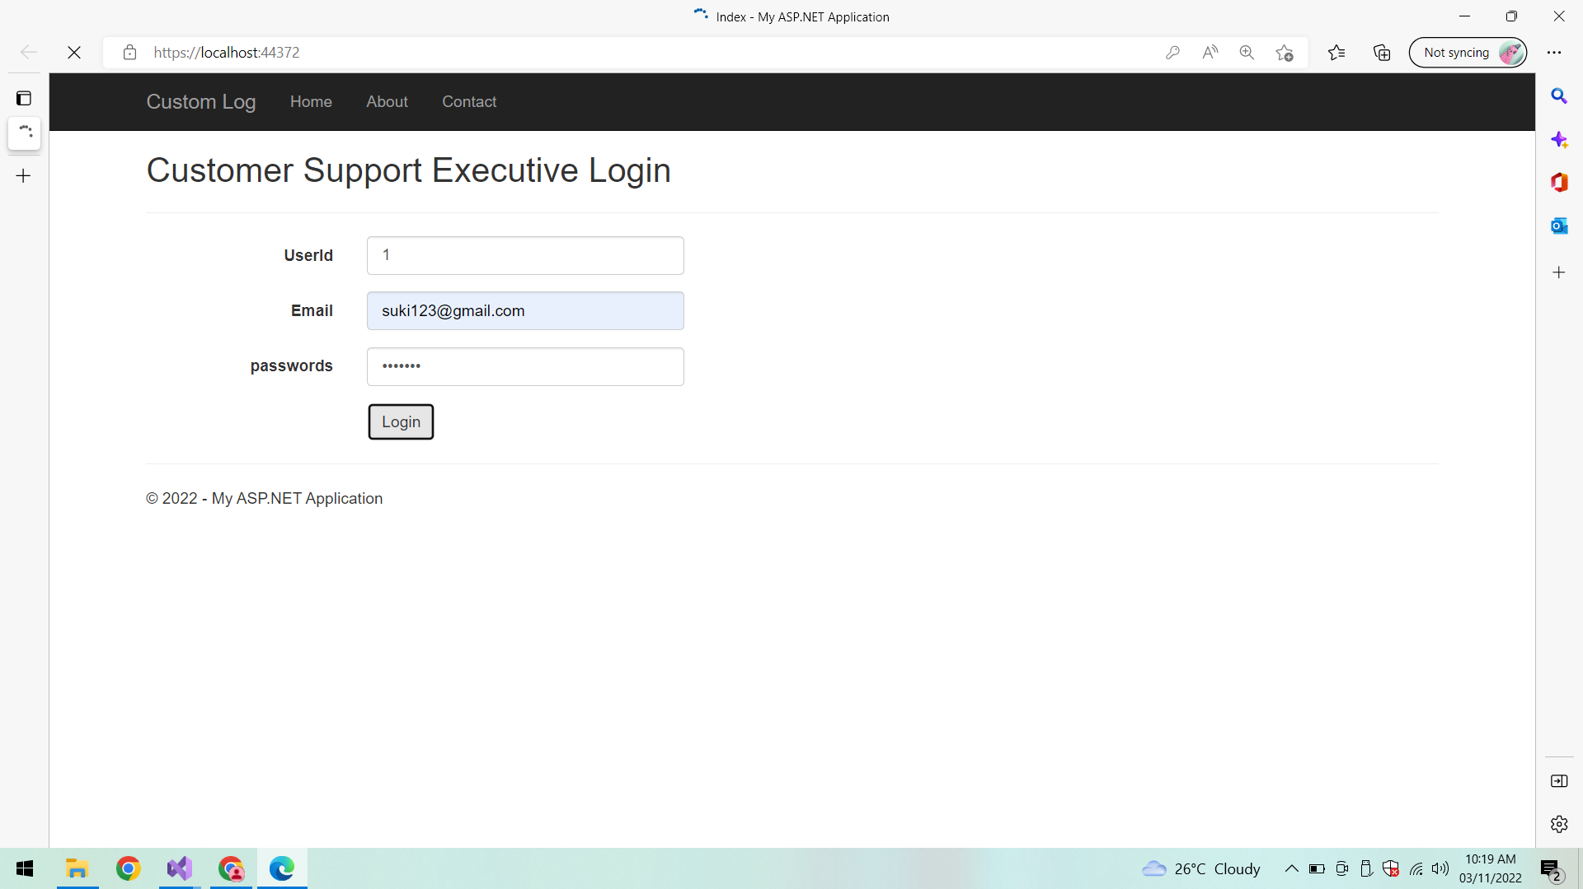

**Dashboard:**

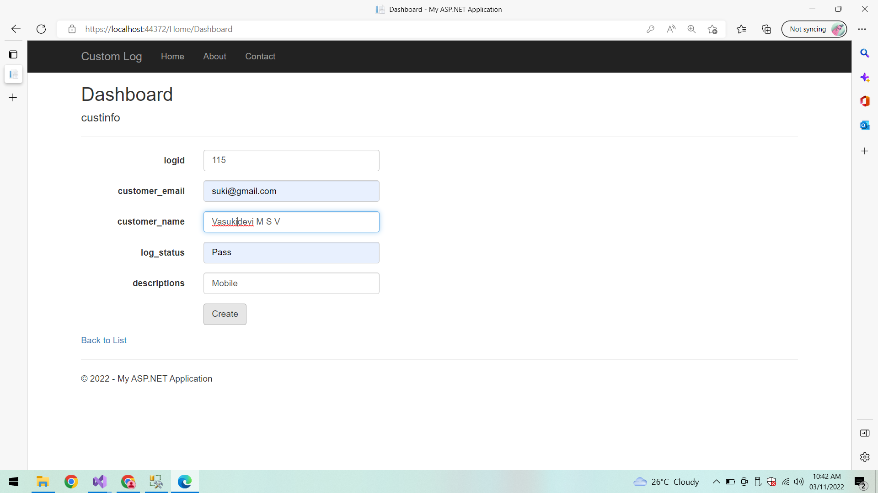

**After Registering complaint successfully Redirects to Login page:**

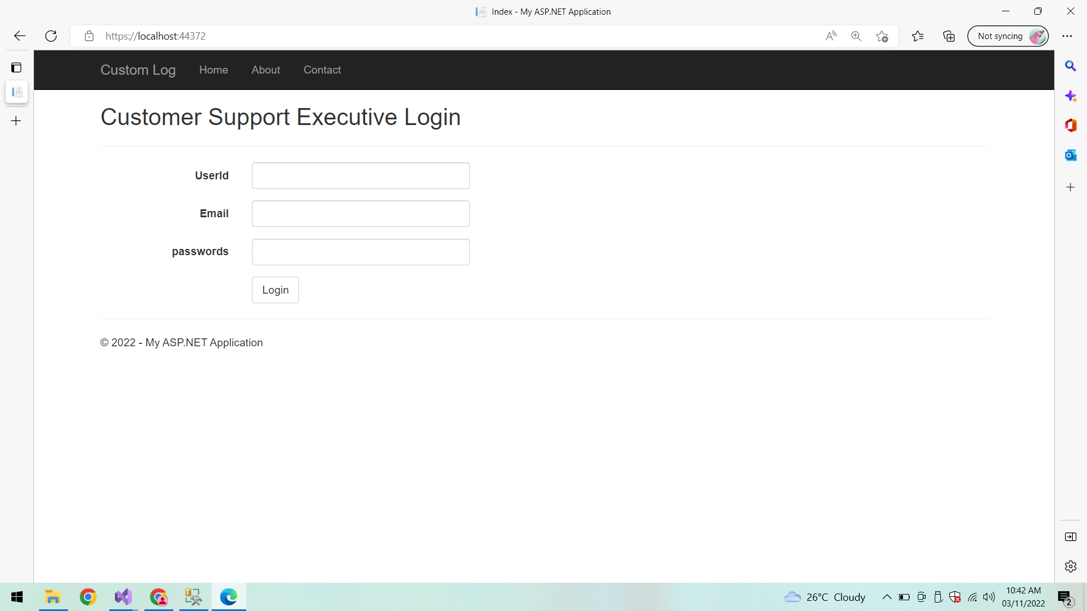

**Verifying results into the database by connecting to SQL Server Management Studio (SSMS):**

**UserInfo:**

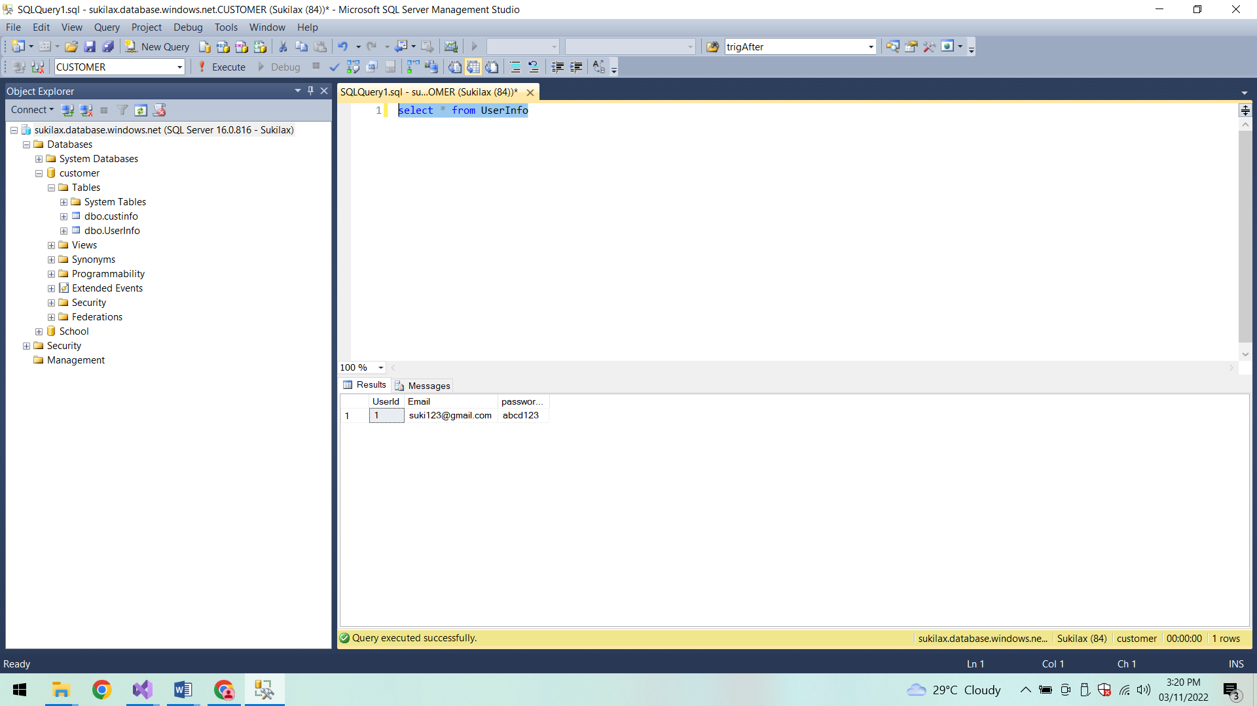

**Customer Support Info:**

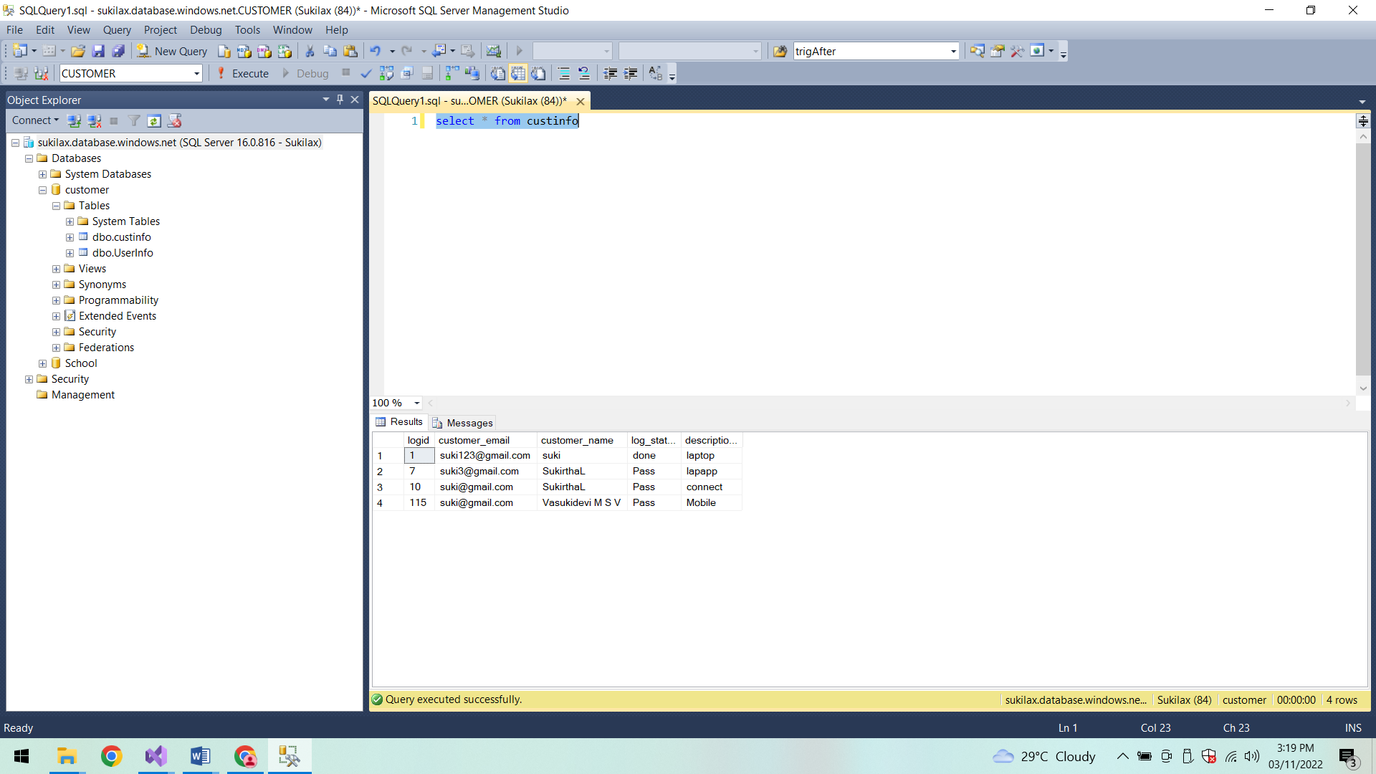

**Model:**

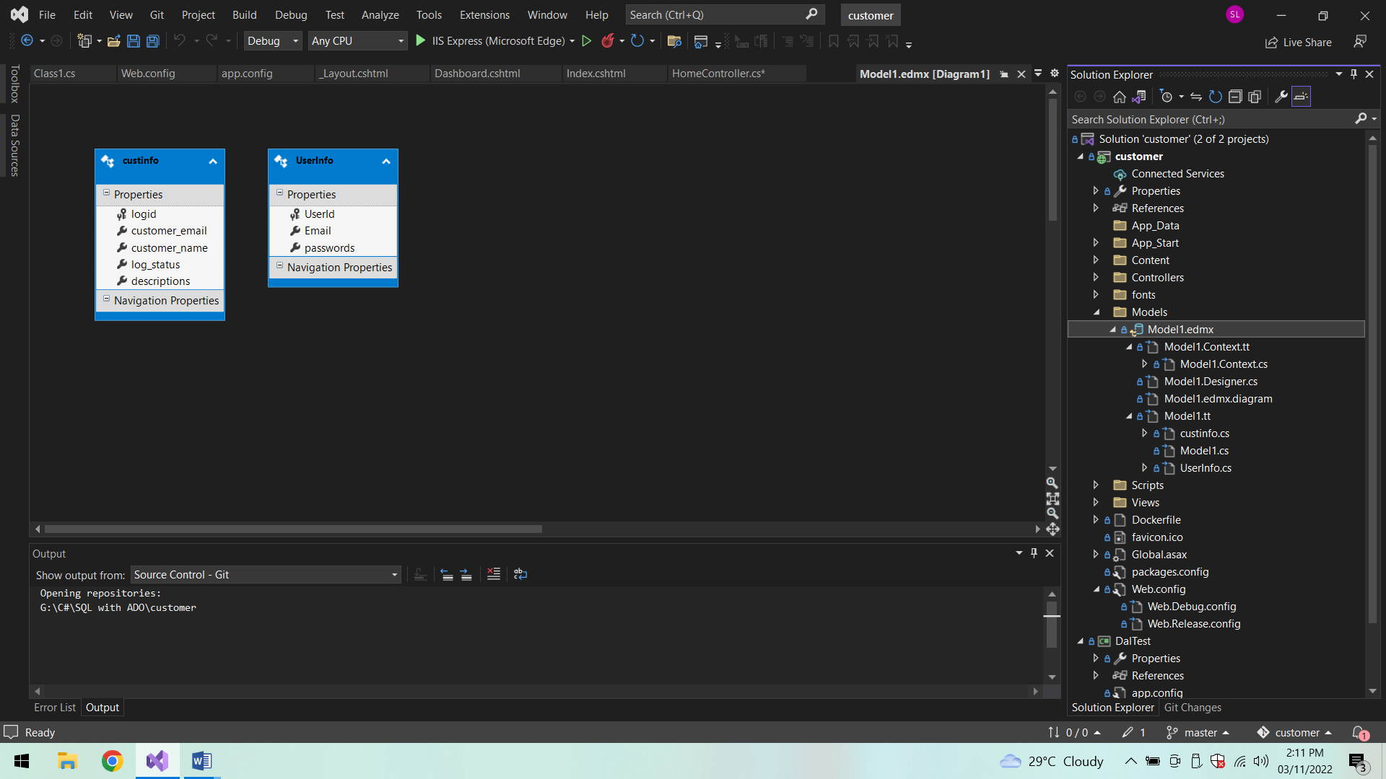

**Jenkins:**

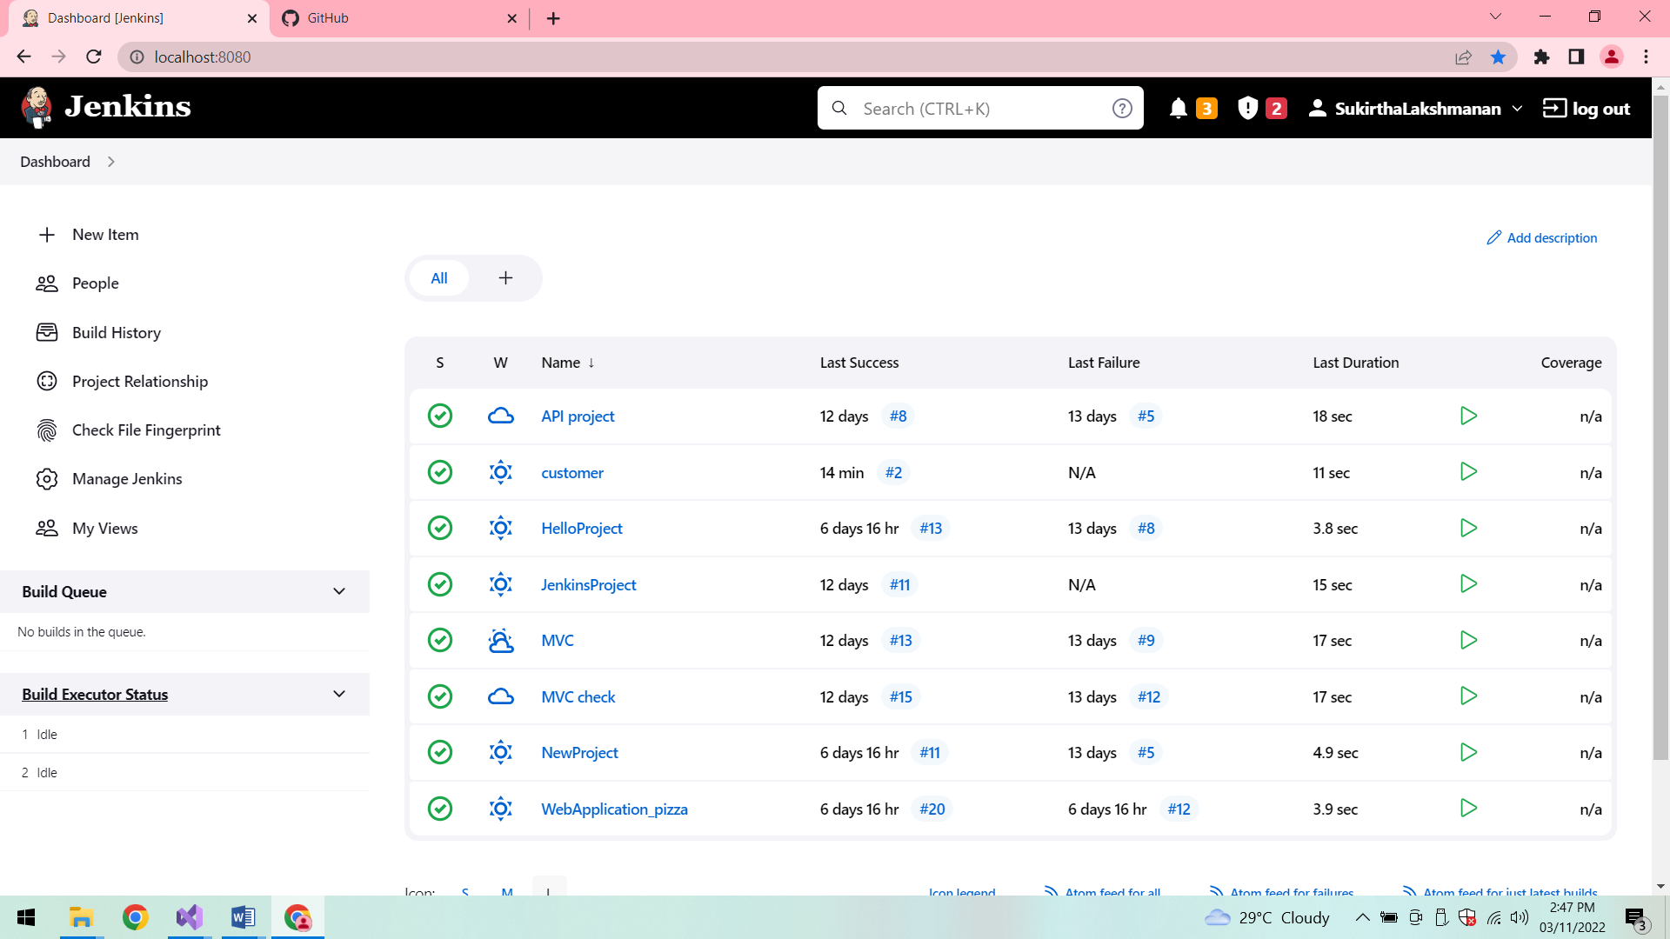

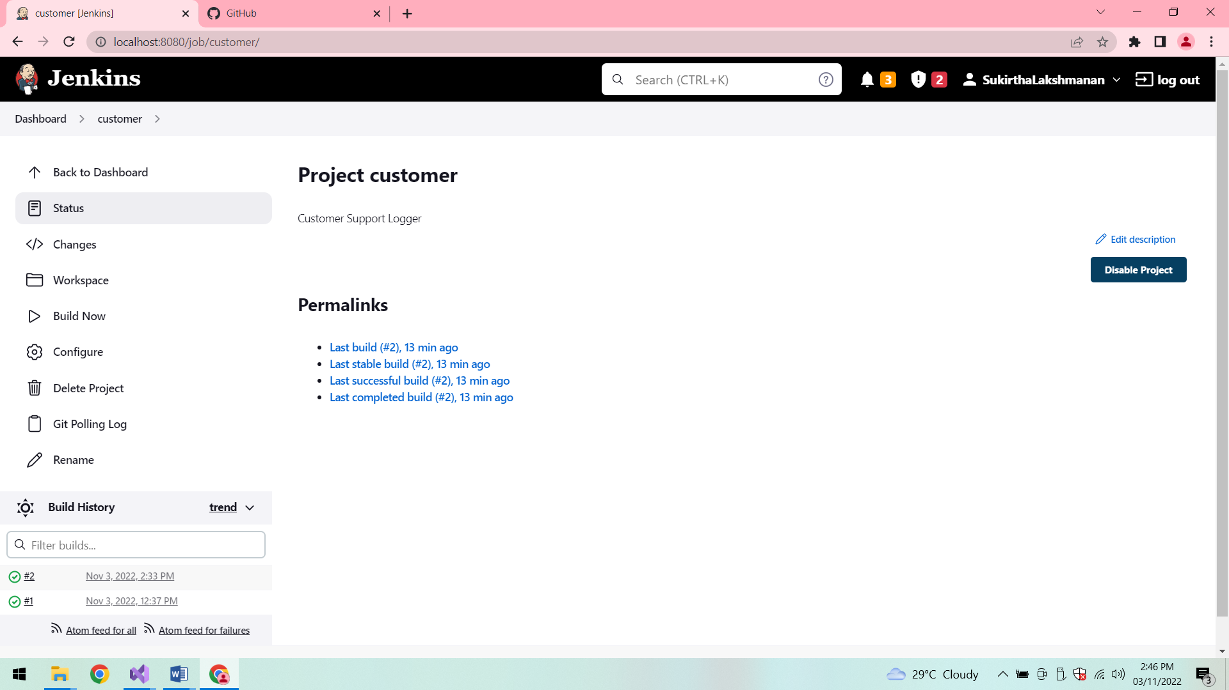

**Console Output:**

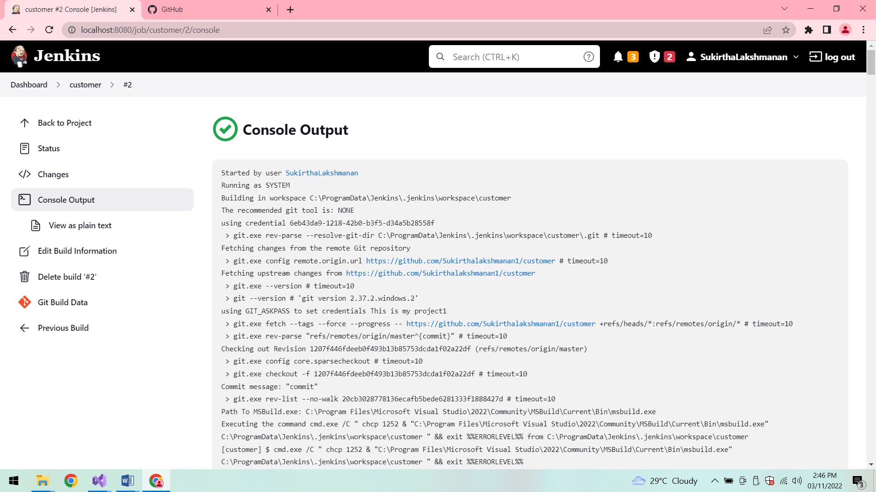

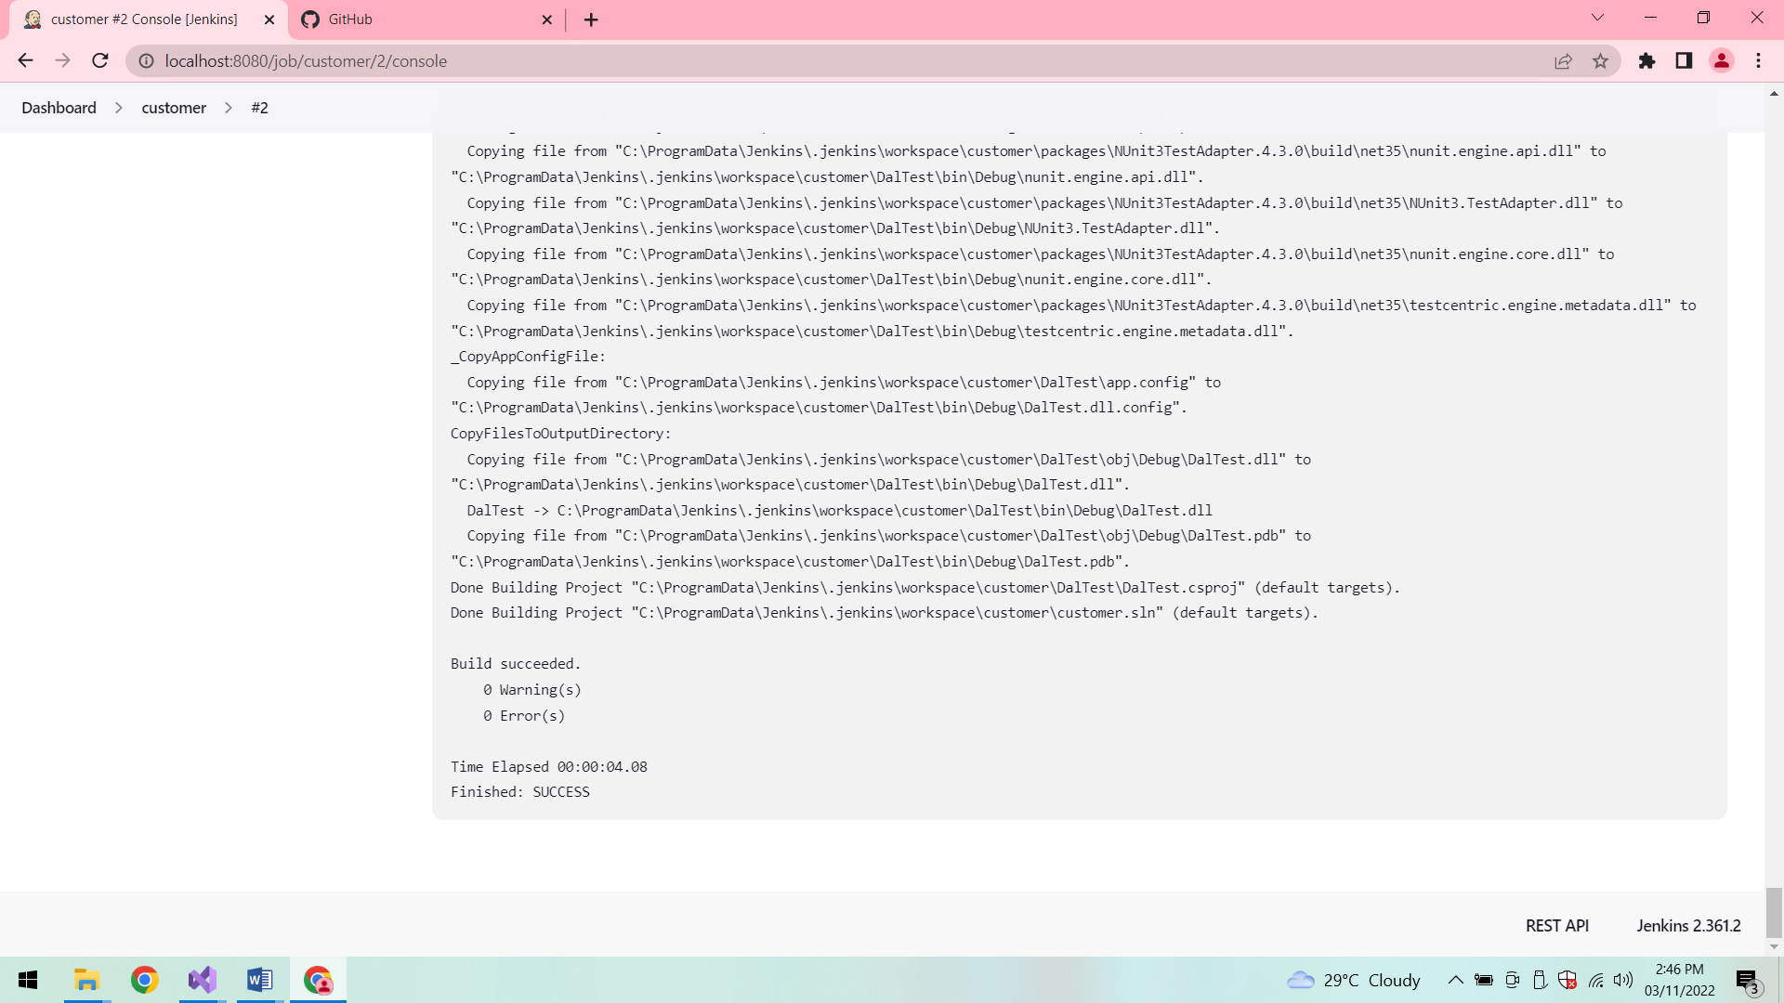

**Build 2:**

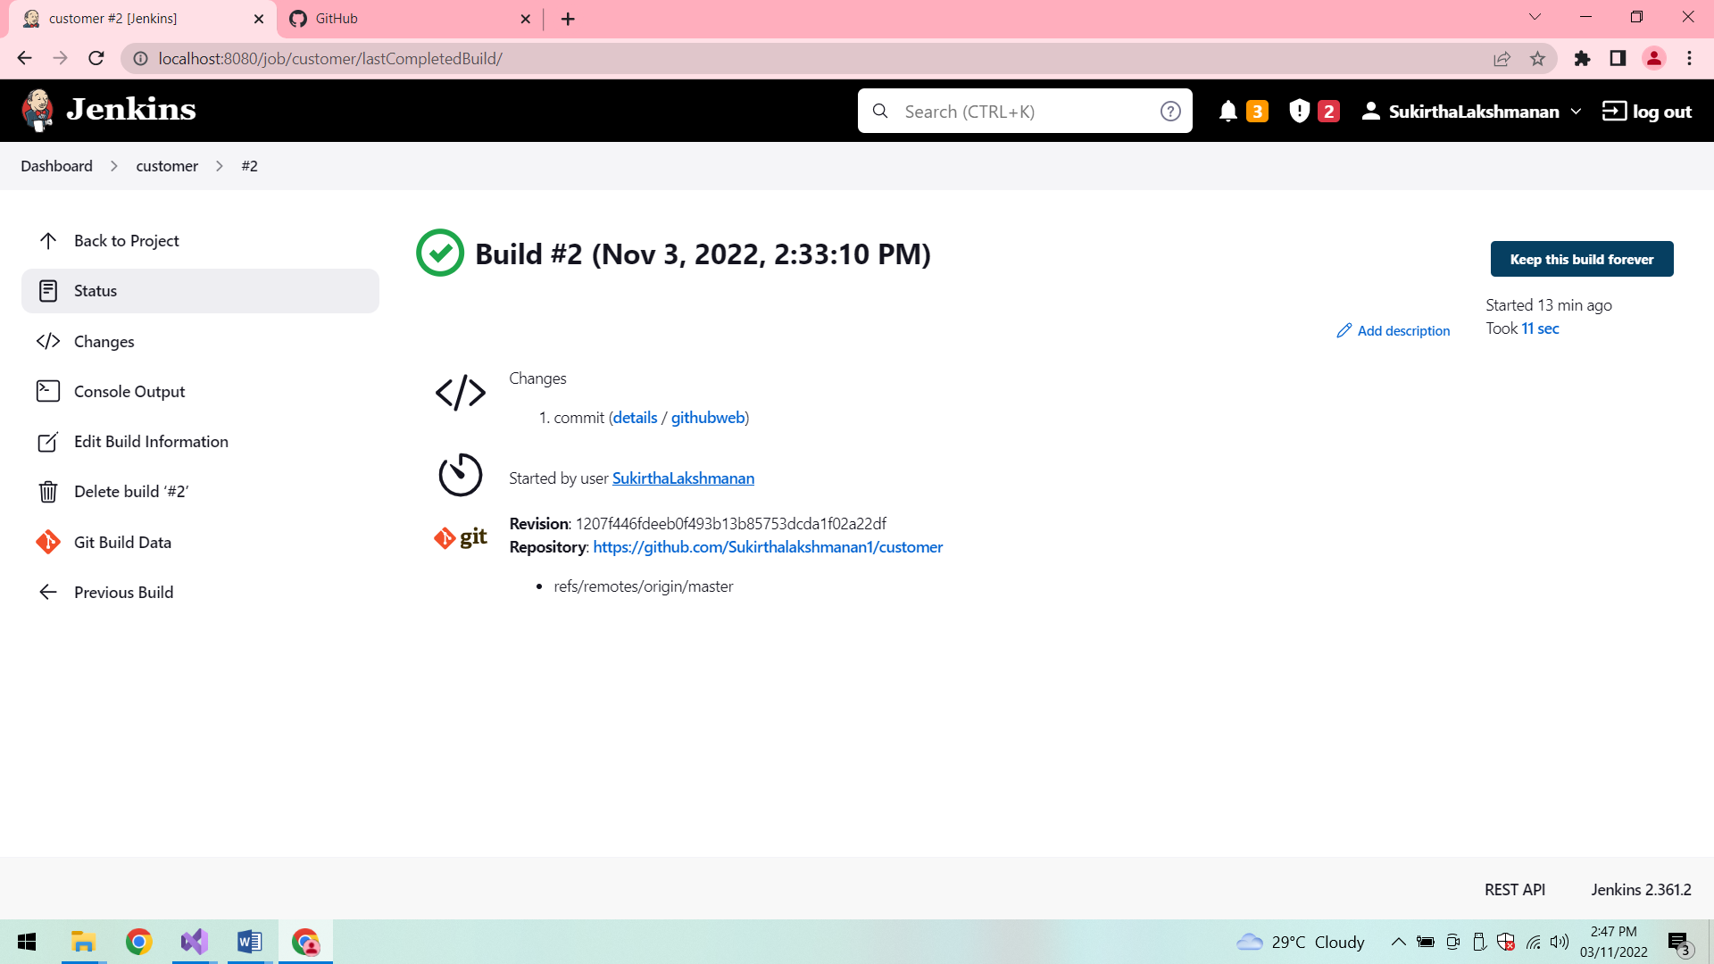

**Poll SCM:**

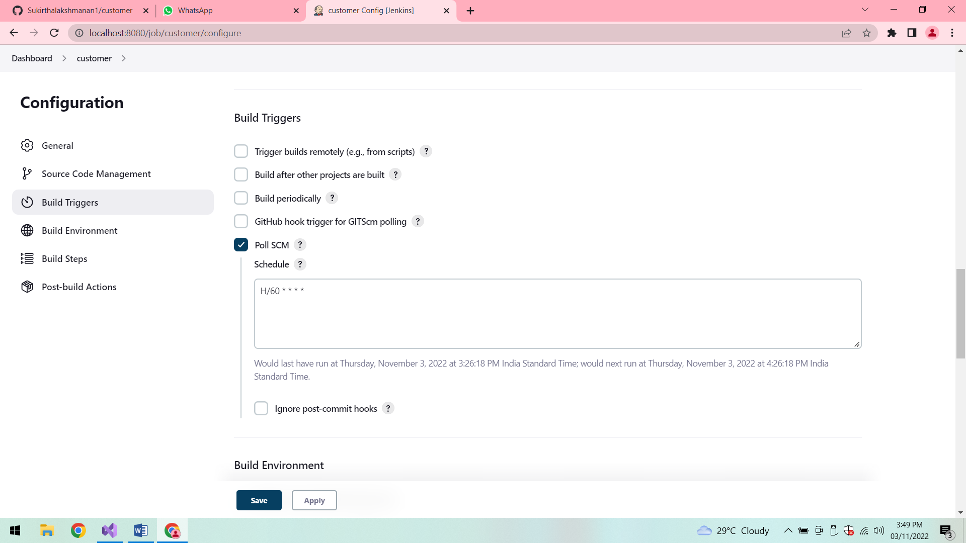

**Build 3:**

